August 23, 2020

Pierce KInghorn 12091381

Data Persistence Application

coit13235 : Assignment 2

Table of Contents

Test Instruction 2

Compile and set up 2

Persistence 4

Retrieval 5

# Test Instruction

## Compile and set up

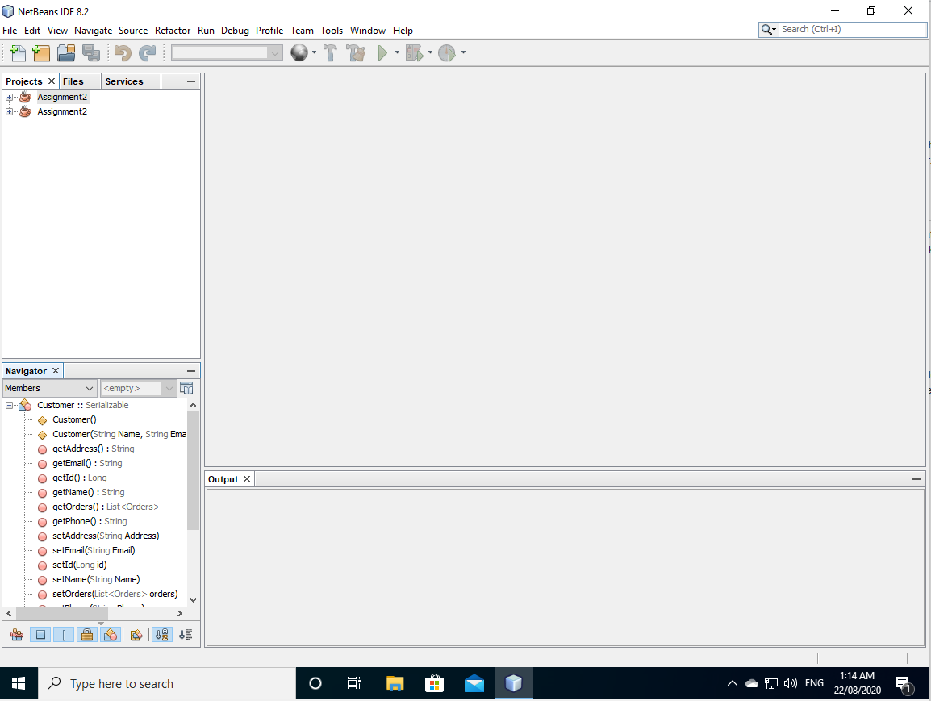*This guide assumes that users already has both Derby, JDK already as well as the NetBeans IDE*

Start by launching the NetBeans IDE and opening the Java Projects.

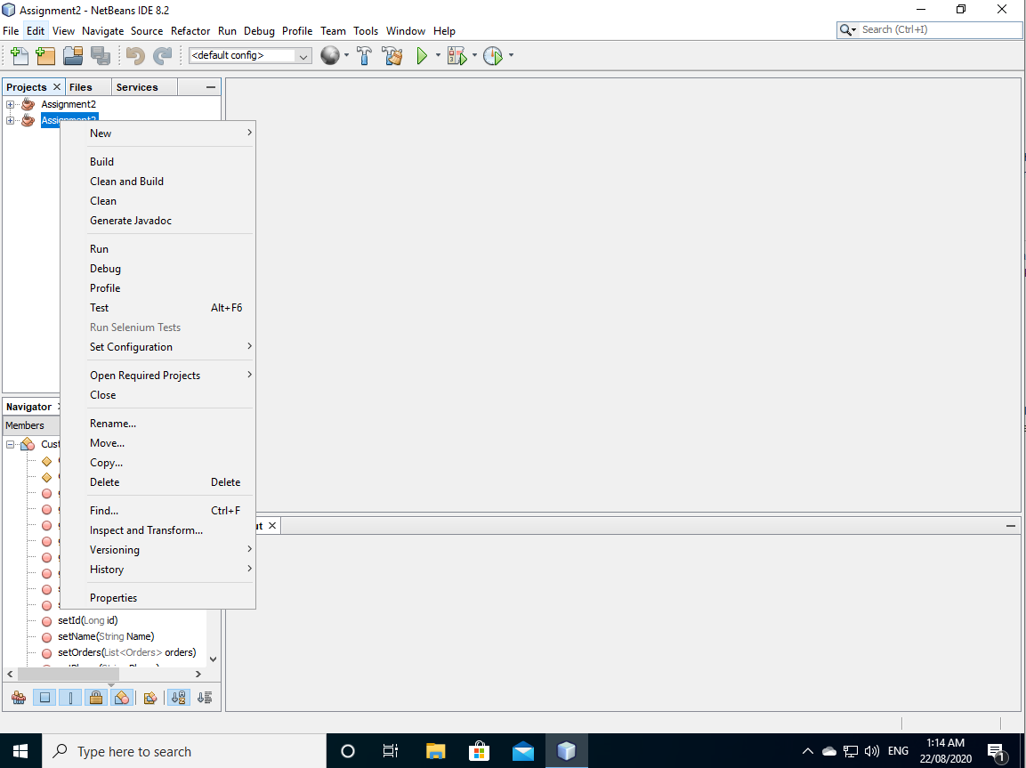

Right click on the project and select “Clean and build” this will build the project into an executable .jar file. This will be done for both projects to create an executable file.

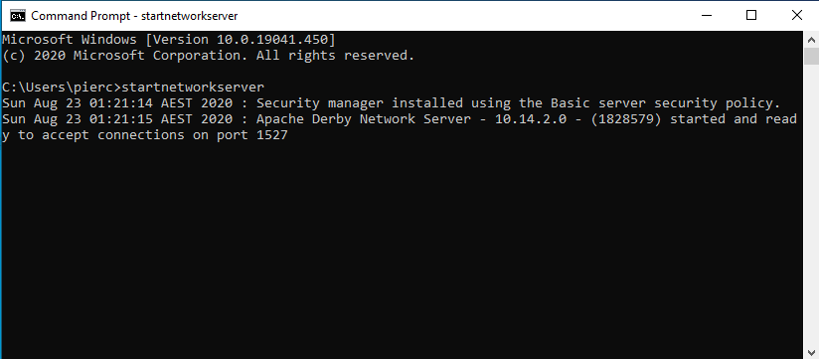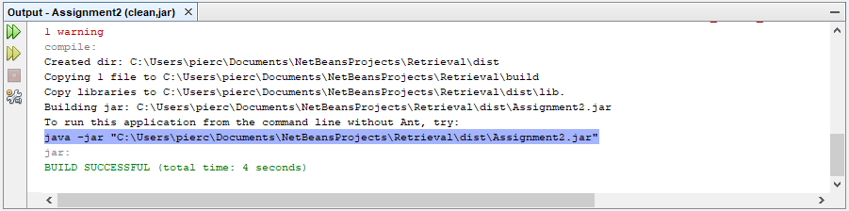Take note of the command line shown within the output box. This will be used to run the java file from cmd.

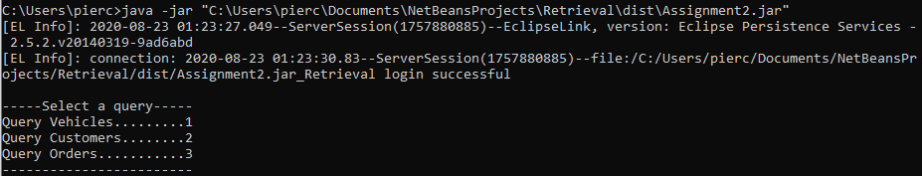Before running the java, file ensure the derby server is running. This is done by typing “startnetworkserver”.

One the server has started type/paste in the command line that was shown in the output box. This will start the java file.

## Persistence

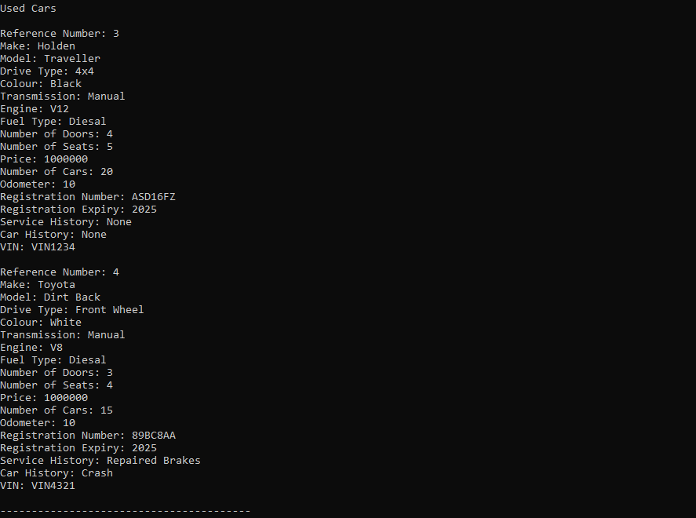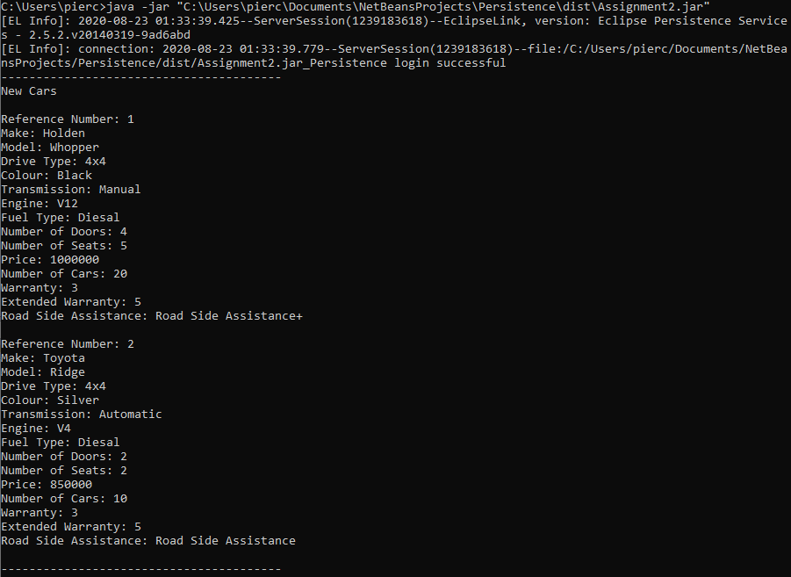To persist the data, perform all the above steps for the persistence project. If done correctly the data should be persisted as below.

## Retrieval

To start retrieval run the command as was shown during the setup instructions. Users will then be prompted to select a query. The rest of the images below will show test cases of each of the queries.

